**HOTEL MANAGEMENT SYSTEM USING MONGO DB**

**A Curriculum Project Report**

***Submitted***

***in the partial fulfilment of the requirements for the award of***

***the degree of***

**MASTER OF TECHNOLOGY**

In

**SOFTWARE ENGINEERING**

By

**R V S TEJA KRISHNA**

**Regd. No. 17MIS7085**



**SCHOOL OF COMPUTER SCIENCE AND ENGINEERING**

**VELLORE INSTITUTE OF TECHNOLOGY-ANDHRA PRADESH**

**UNIVERSITY**

**AMARAVATI (BESIDE AP SECRETARIAT)**

**INAVOLU, GUNTUR – 522237, INDIA**

**2020**

**CONTENTS**

|  |  |  |
| --- | --- | --- |
| **NO** | **TITLE** | **PAGE NO** |
| **1** | **INTRODUCTION** | **3** |
| **2** | **PROPOSED SOLUTION ON SYSTEM** | **4** |
| **3** | **FEASIBILITY STUDY** | **5** |
| **4** | **SYSTEM DESIGN** | **6** |

**CHAPTER – 1**

**INTRODUCITON**

Our project on **“Hotel Management System”** gives idea about the management in hotels. The package gives all the information regarding check in or check out facilities of the customer. The customer can make his or her booking for room and food. It gives the details of the customer and the time of arrival and departure of customer. The package also provides the facility of searching the customer in that particular hotel by mobile number. This software is very useful to the departments for managing their activities.

Although, hotels are already having well-developed software for information management, we just want to study how this is done. So, we selected hotel management system as our project. We visited various hotels and gone through their software. In most of the hotels the back-end used only MS-ACCESS. We have includes NoSQL database i.e., Mongo DB.

Developing software like **“Hotel Management System”** has much scope. It can be made more attractive and many more modules can be attached to provide various services to customers. Our project provides various services to customers like booking (advance/ current), cancellation of advance booking, enquiring about any customer (by mobile number/ name) or about room availability. The project has Scope in hotels since the routine activities of managing departments become easy.

**CHAPTER – 2**

**PROPOSED SOLUTION ON SYSTEM**

**Hotel Management System** is a project to maintain the record of customer details who booked a room in that particular hotel. With the help of this project we reduced task deployed for data/information collection to a large extent thereby eliminating human errors considerably.

Therefore the organization has realized the need for automating the various daily routine activities of hotel & task of data/information collection with the help of database designing.

**Advantages of proposed system**

* Huge reduction in number of pages being used for the data storage.
* Back up facility provided in case of data loss.
* Reduction in cycle time till the updated data will be available.
* Speedy retrieval of data.
* Compatible with the advance versions for future perspective.
* Cost benefits.

**CHAPTER – 3**

**FEASIBILITY STUDY**

The objective of feasibility study is to determine whether or not the proposed system is feasible. The feasibility is determined in terms of three aspects. These are:-

1. **Technical Feasibility**

In this, one has to test whether the system can be developed using existing technology or not. We have used Java as front-end and Mongo DB as back-end. It is evident that necessary hardware and software are available for development and implementation of proposed system. We acquired the technical knowledge of working in Java programming language, and then only we have started designing our project.

1. **Behavioral Feasibility:**

The hotels are already using various software for managing their information and since it is acceptable by both hotel administration as well as hotel staff, it is proven to be operationally feasible.

1. **Economic Feasibility:**

As a part of this, the costs and benefits associated with the proposed system are compared and the project is economically feasible only if tangible and intangible benefits outweigh the cost. The cost for proposed hotel management system in outweighing the cost and efforts involved in maintaining the registers, books, files and generation of various reports. The system also reduces the administrative and technical staff to do various jobs that single software can do. So, this system is economically feasible.

1. **Legal Feasibility:**

Legal feasibility determines whether the proposed system conflicts with legal requirements, e.g. the Data Protection Act. It will be done by some legal advisors.

**CHAPTER – 4**

**SYSTEM DESIGN**

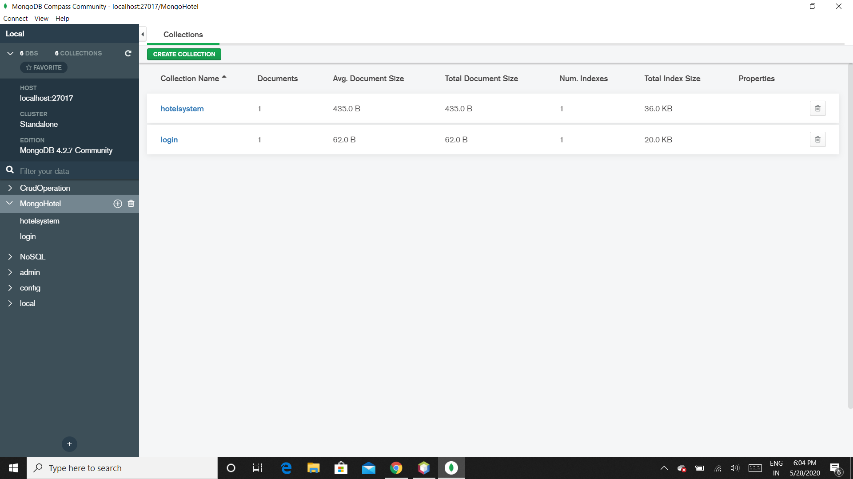

**Fig 4.1 collections in database**

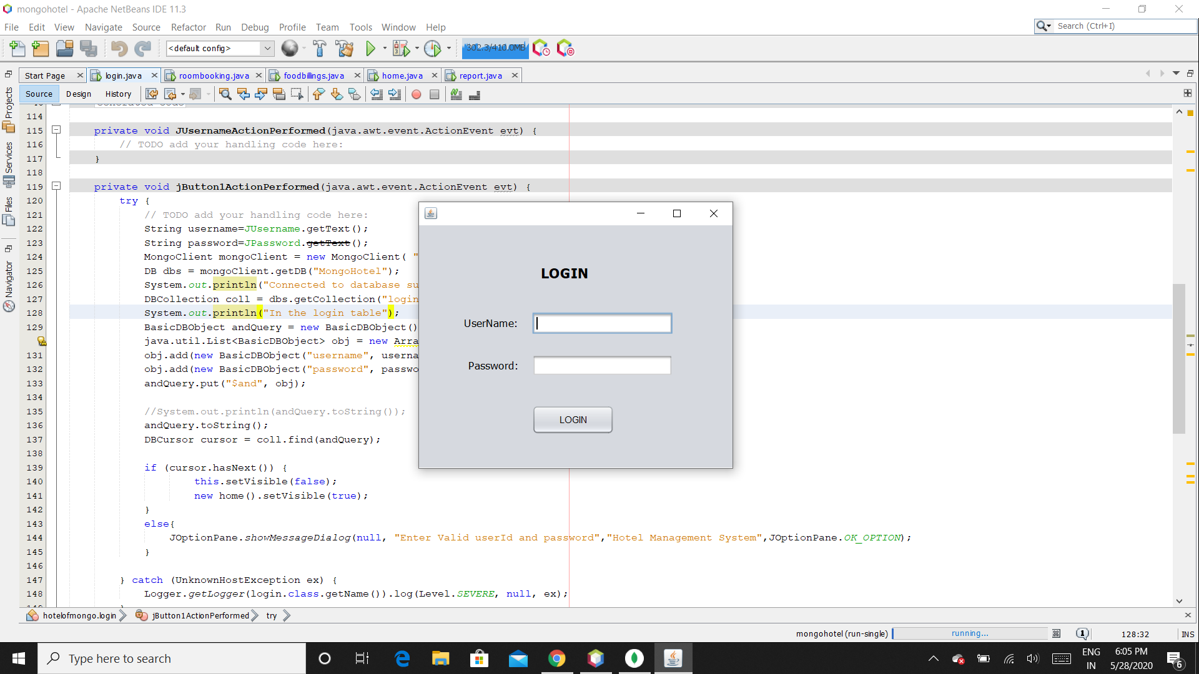

**Fig 4.2 Login page**

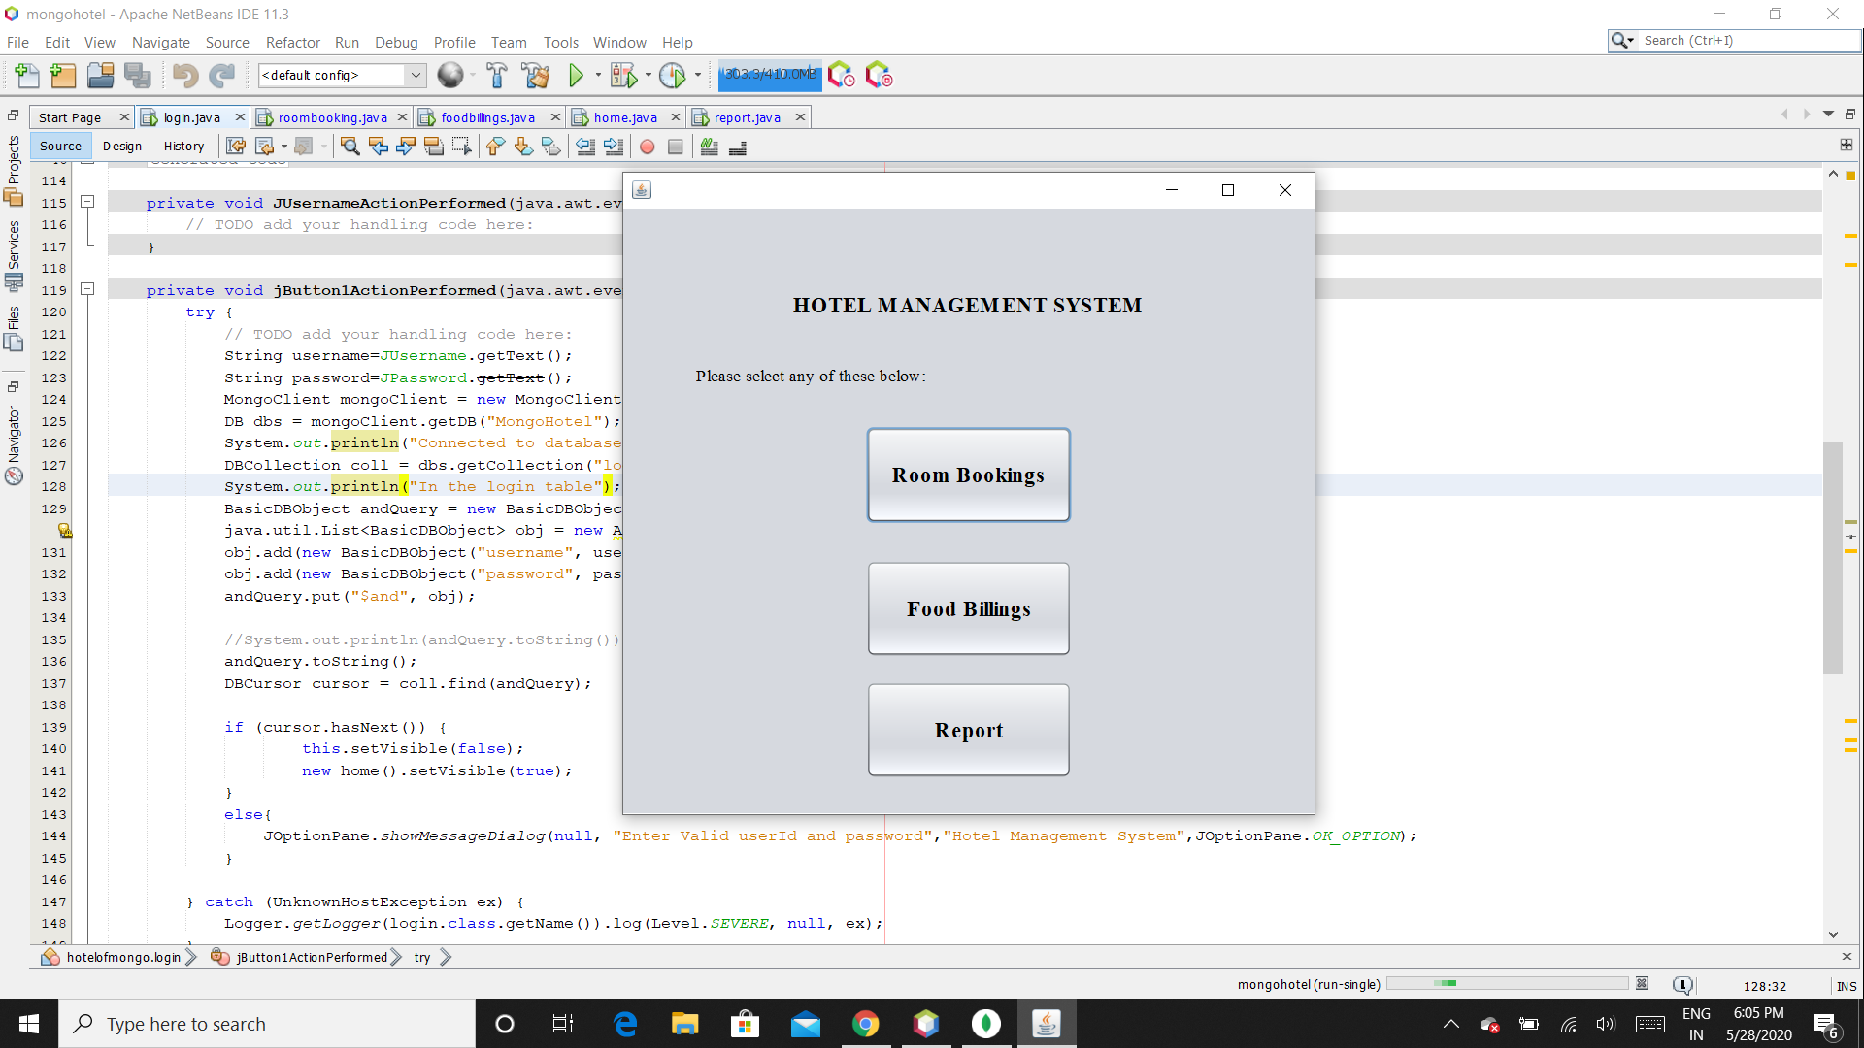

**Fig 4.3 Home page**

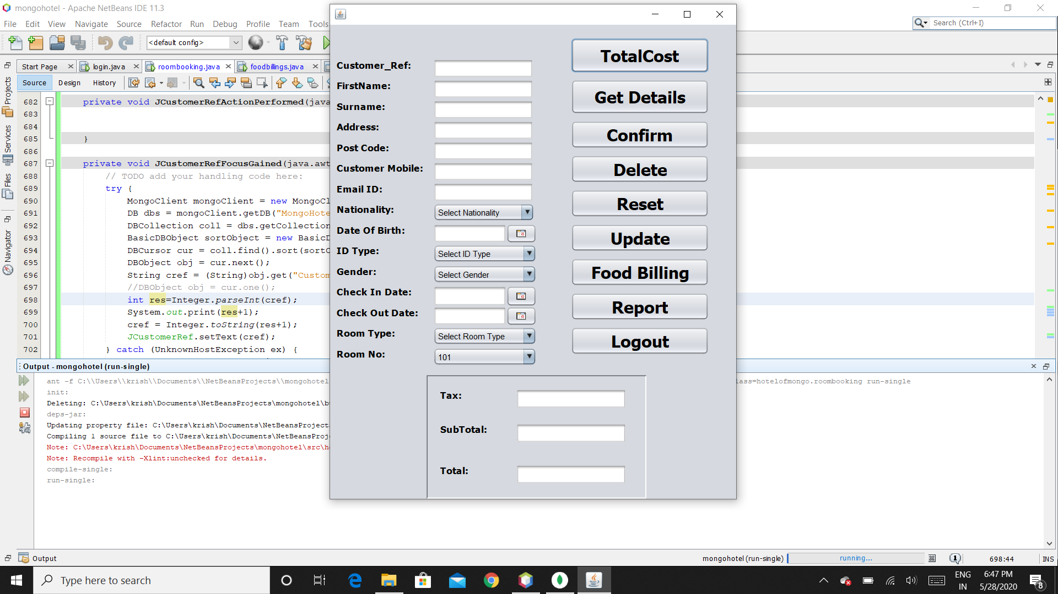

**Fig 4.4 Room Bookings page**

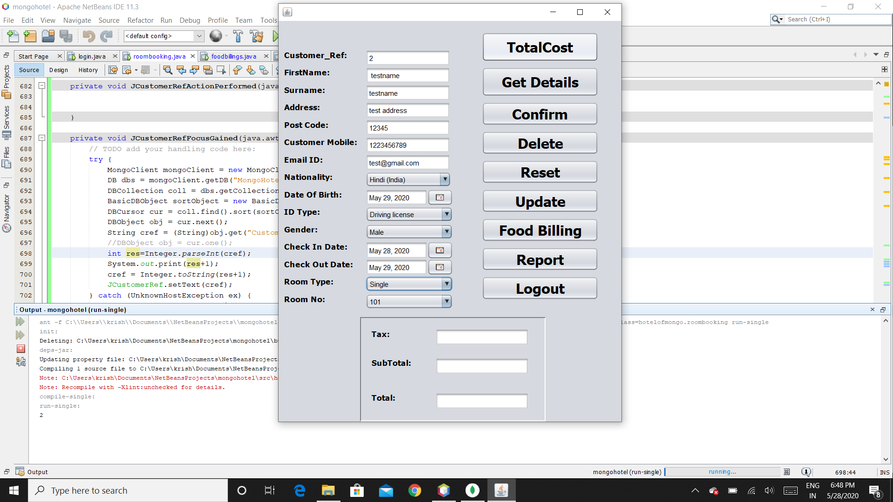

**Fig 4.5 Entering room booking details**

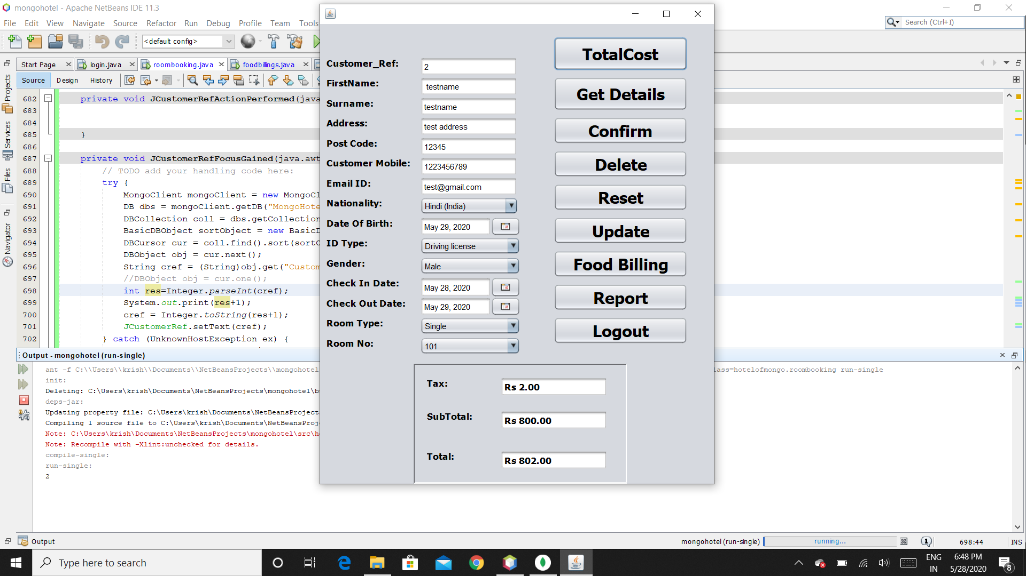

**Fig 4.6 Click on TotalCost for calculating cost**

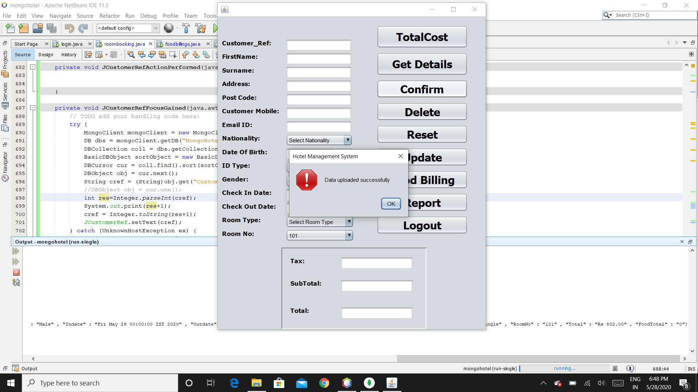

**Fig 4.7 confirm your booking**

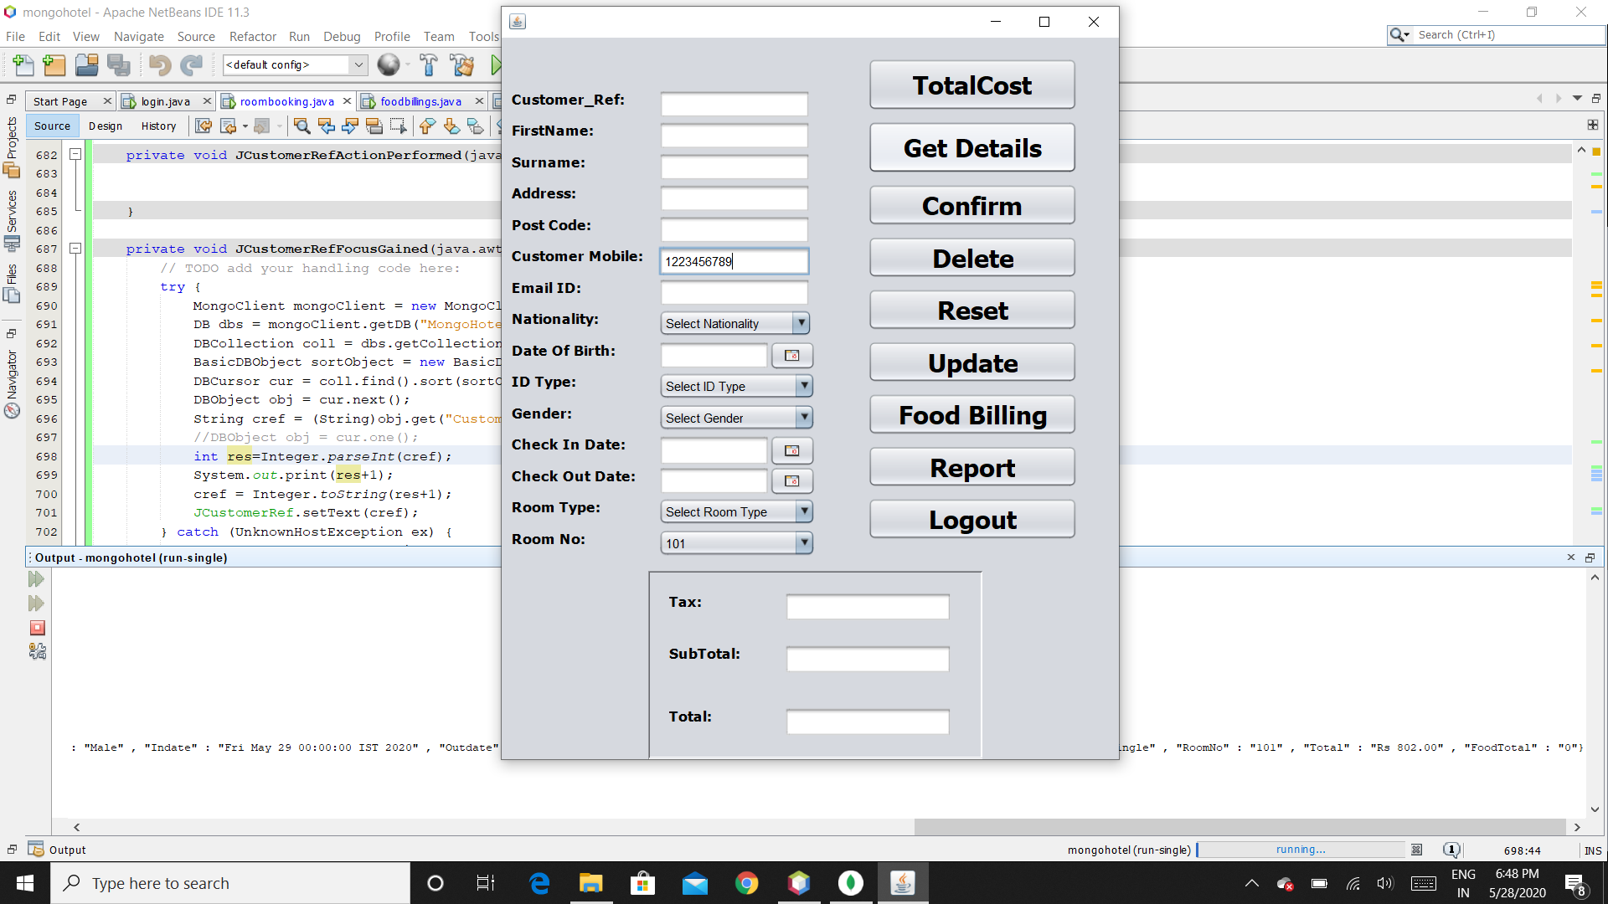

**Fig 4.8 To update enter the mobile number and click Get Details**

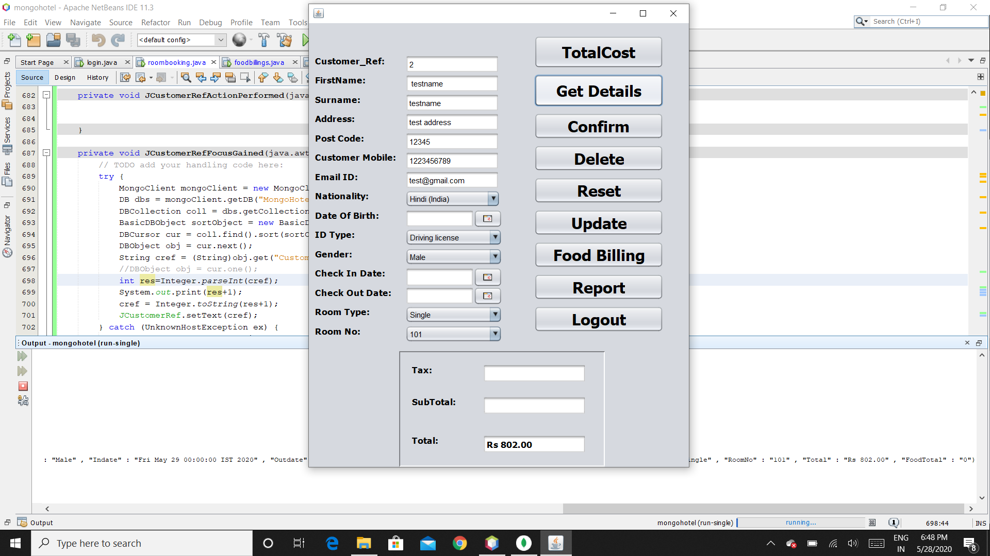

**Fig 4.9 values after clicking on Get Details button**

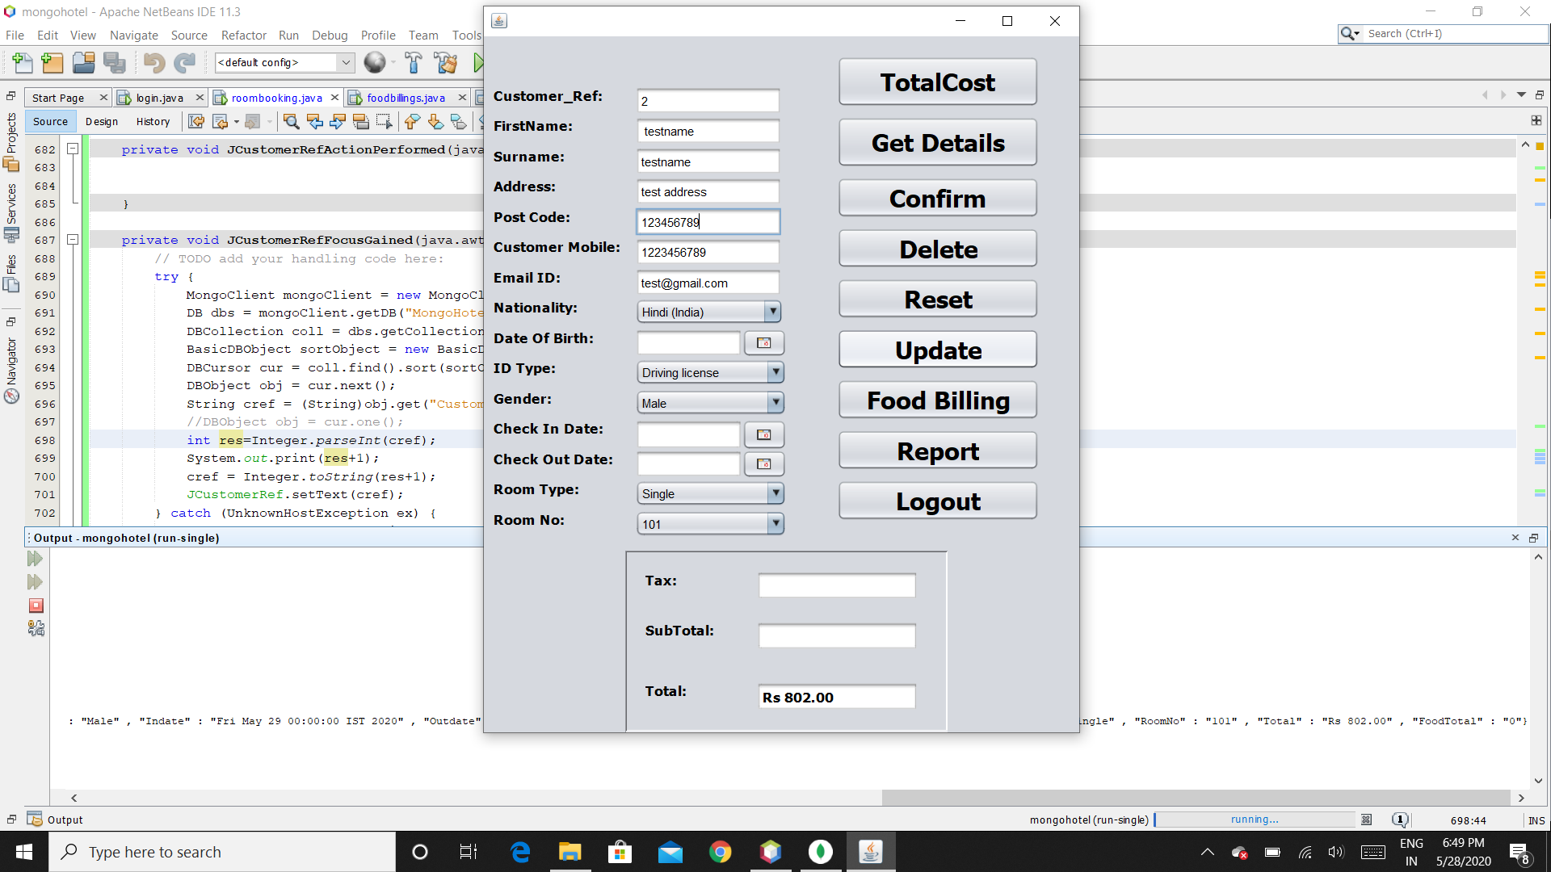

**Fig 4.10 changing the post code value for suppose and click Update**

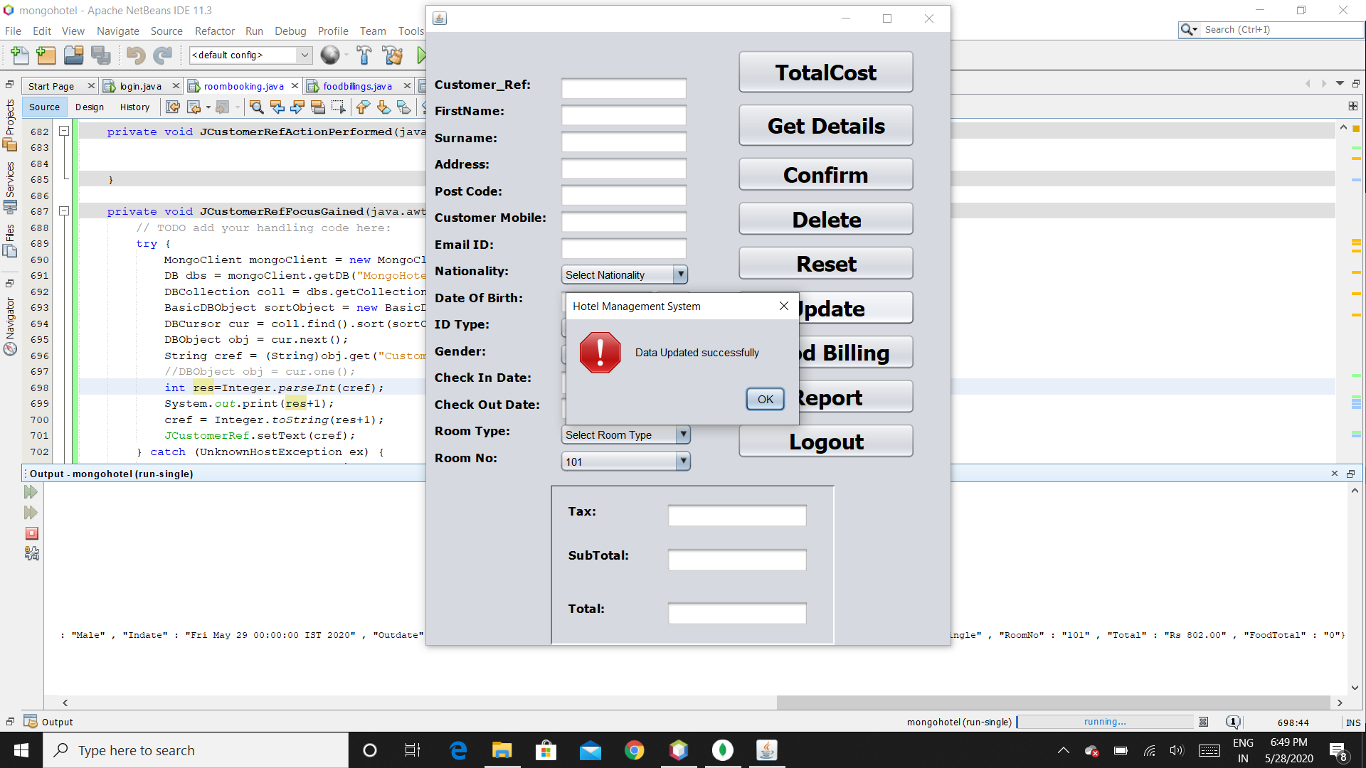

**Fig 4.11 confirmation for update successful.**

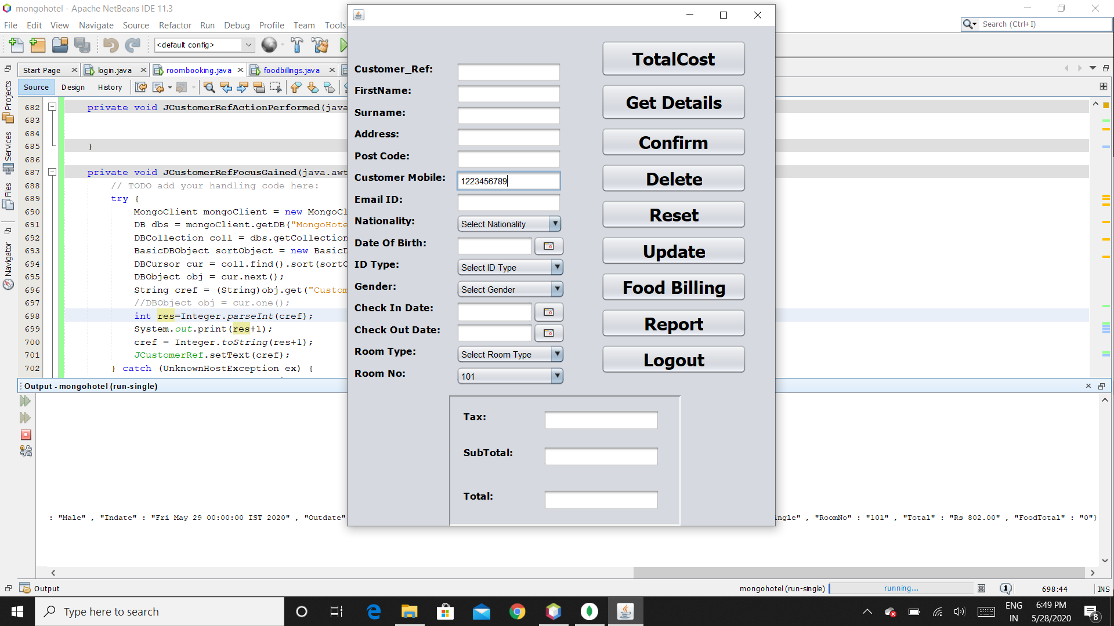

**Fig 4.12 To delete an entry enter the mobile number and click Delete**

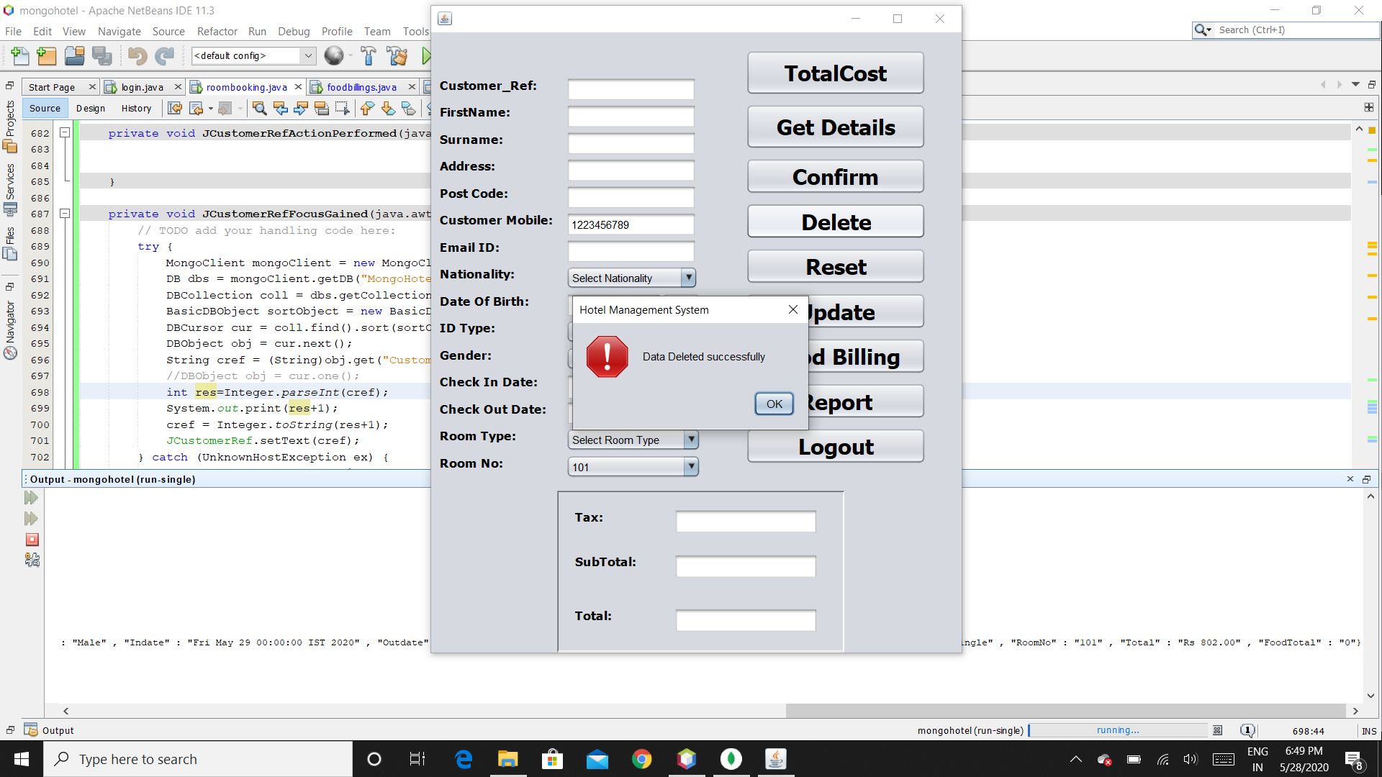

**Fig 4.13 confirmation for delete successful**

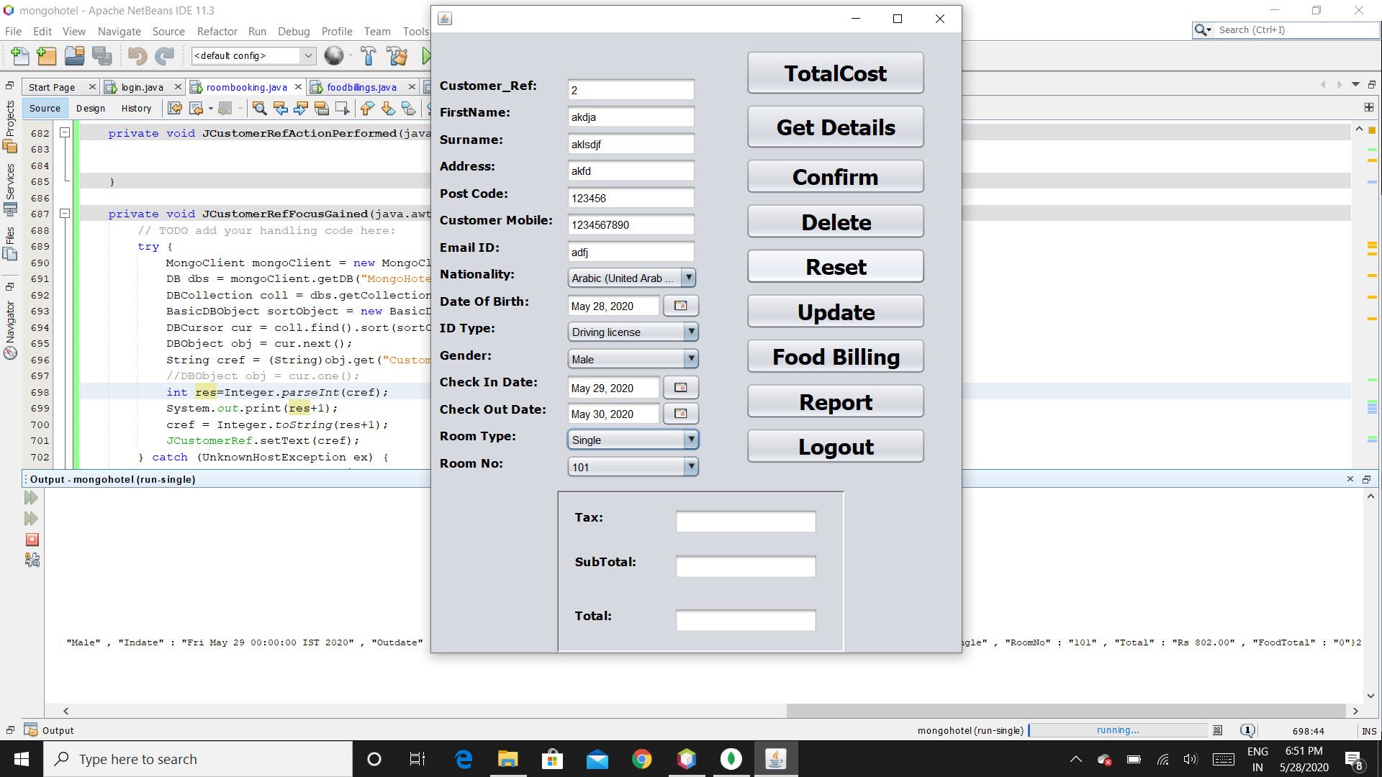

**Fig 4.14 Clear all values in the form click Reset gives empty form.**

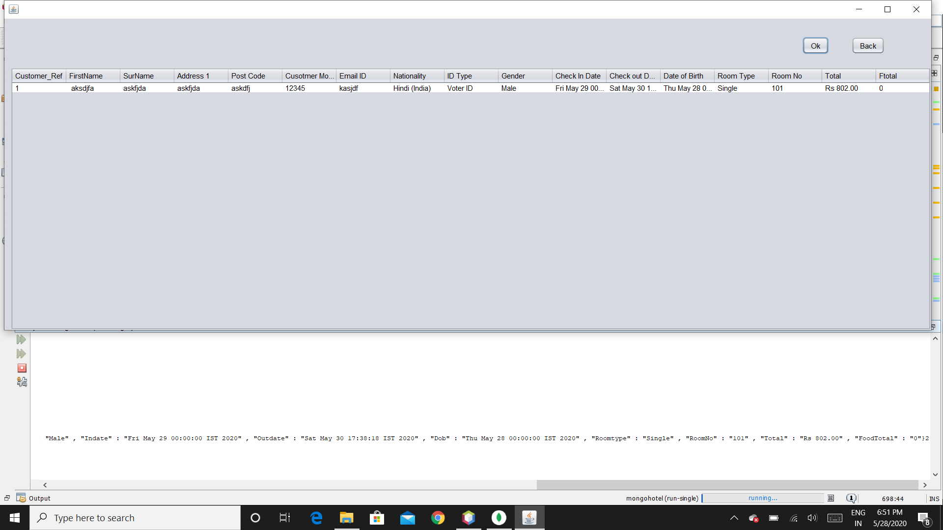

**Fig 4.15 Report page to get all booking details.**

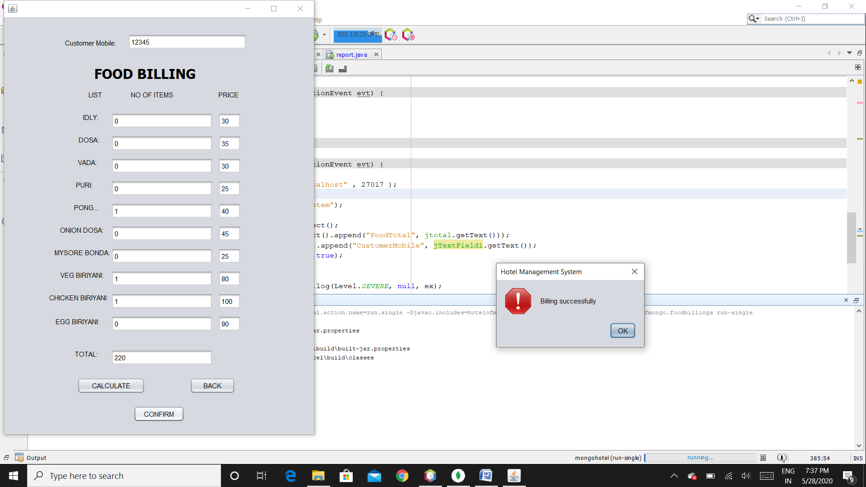

**Fig 4.16 Food Billing Page enter the mobile number and add the quantity click on calculate to get the total and finally to save the transaction click on Confirm**

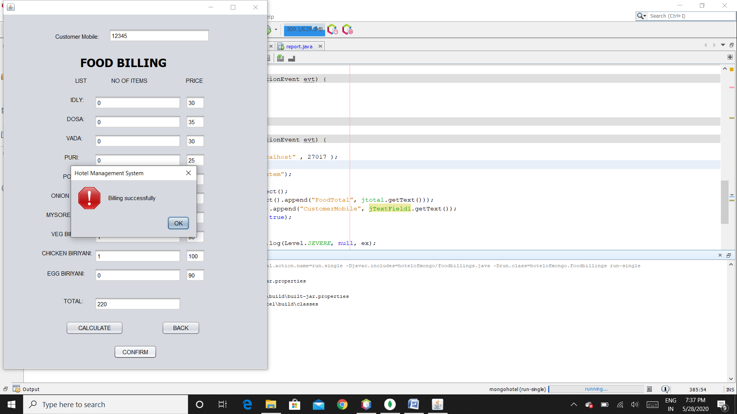

**Fig 4.17 confirmation for successful billing**